DESIGN SP TECHNICAL DOCUMENT
2019
Version 1.0
Document Information
Document Title: | Design SP Technical Document
File Name: | Onebook Site Builder-Design SP Technical Document
Author(s):

Document Acceptance
Reviewed By
Designation: | Designation: | Designation: | Designation:
Date: 20190425 | Date: | Date: | Date:

Approved By
Designation: | Designation: | Designation: | Designation:
Date: | Date: | Date: | Date:
Document Revision History
Date | Version | Author | Description
12 Apr 2019 | 1.0 | Ada Truong | Initial document
25 Apr 2019 | 1.1 | Amanda, Winnie | Create Licensee

Onebook site builder
vn team
Table of Contents

1 Introduction 4
1.1 Objectives 4
1.2 Roles and Responsibilities 4
2 Workflow 5
3 design sp 6
3.1 NAP_Admin_VerifySiteName 6
3.2 Dot_Dep_CreateLicensee 6
3.3 Acc_Dep_CustomerInsMember_Com 8
3.4 Acc_Dep_CustomerInsMember_Sag 13
3.5 Acc_Dep_CustomerInsMember_Mag 17
3.6 Acc_Dep_CustomerInsMember_Ag 22
3.7 Acc_Dep_CustSetting_PositionTakingSettingUpd 26
3.8 Acc_Dep_CustSetting_BetLimitFullLineUpd 27
3.9 Acc_3rdProductUpdSuperStatus 27
3.10 Acc_BA_LicConfigUpd 28
3.11 Acc_BA_GroupCurrencyUpd 28
3.12 Dot_Dep_LM_CreateNewLicensee 29
3.13 Nap_LM_Licensee_Insert 33
3.14 Nap_LM_Licensee_AddAgent 34
3.15 Nap_LM_Licensee_OfferProduct 34
3.16 Nap_LM_Licensee_EnablePlayerComm 35
3.17 LicenseeBAConfig 36

INTRODUCTION

Objectives
The document describes Store Procedures which were provided by VN team, for Onebook Site Builder system.

Roles and Responsibilities
No | Role | Name | Responsibility
1 | Project Manager | TWN:  VN: Ben
2 | Business Analyst | TWN:  VN: Ada
3 | Technical Leader | TWN:  VN:
4 | Developers | TWN:  VN:
5 | QA | TWN:  VN:

WORKFLOW

Current state
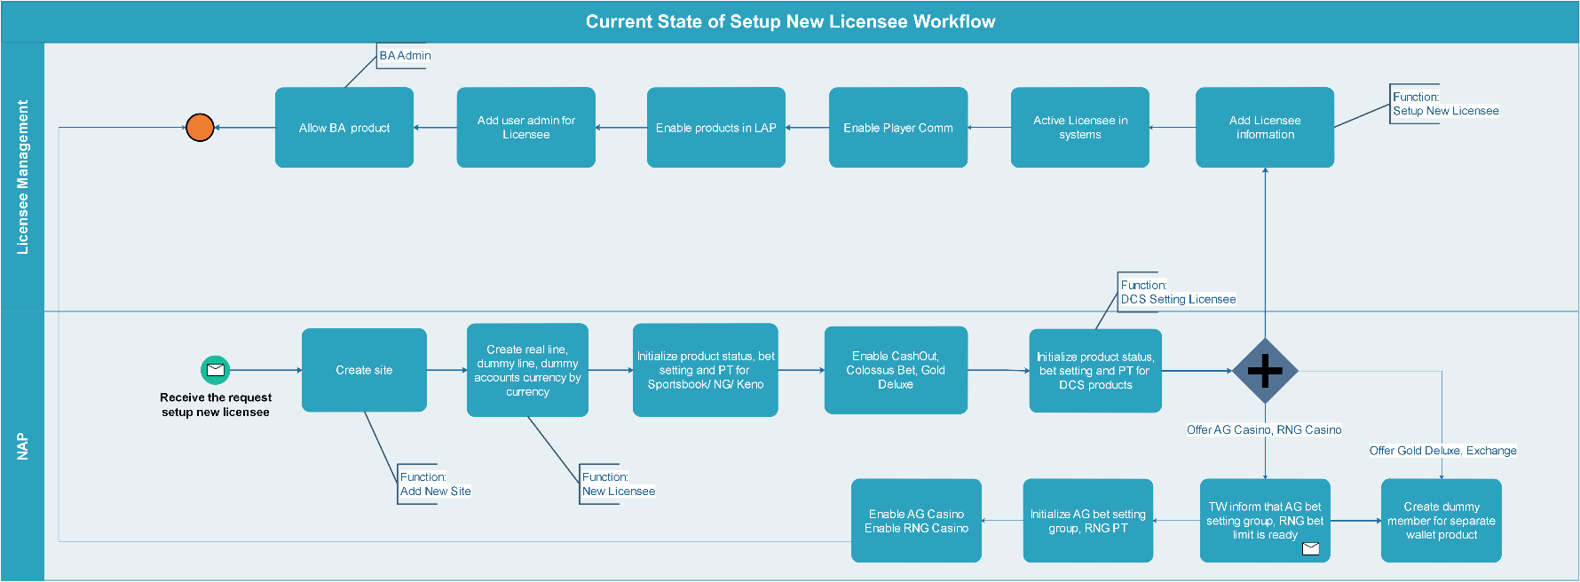

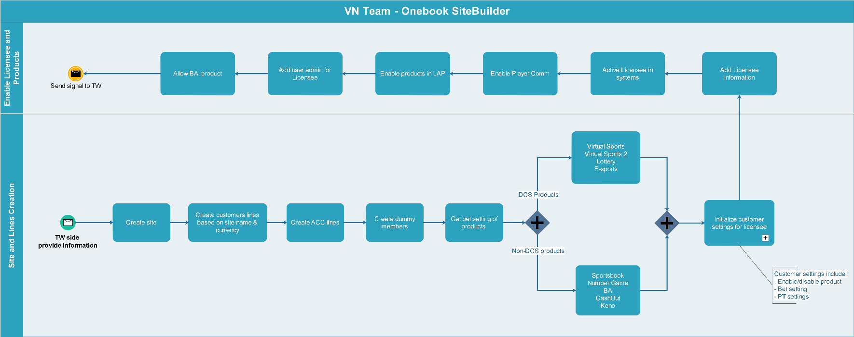
VN part in Site Builder

Supported Products
# | Category | Product | Enable product | Bet setting | PT setting | BA Commission
1 | Old structure setting | Sportsbook | Enable | Provided SB bet setting | 12% | -
2 | Old structure setting | Number Game | Enable | Provided NG bet setting | 12% | -
3 | Old structure setting | BA | Enable | - | - | 0.25%
4 | Old structure setting | Keno | Enable | Provided Keno bet setting | 10% | -
5 | Old structure setting | CashOut | Enable | - | - | -
6 | DCS | Virtual Sports | Enable | Provided VS bet setting | 12% | -
7 | DCS | Virtual Sports 2 | Enable | Provided VS bet setting | 12% | -
8 | DCS | Lottery | Enable | Provided Lottery bet setting | 10% | -

DESIGN SPs

Validate sitename availability
Functionality: Validate if sitename is available.
SP name: NAP_Admin_VerifySiteName
Input parameters:
Parameter | Type | Mandatory | Description
Sitename | String | Yes

Return parameter:
Parameter | Type | Mandatory | Description
Errorcode | Number | No | ErrorCode= 0: sitename is available  ErrorCode= 101: sitename is unavailable
ErrMsg | String

3.2. Create Licensee
SP name: Dot_Dep_CreateLicensee
Input parameters:
Parameter | Type | Mandatory | Description
Product | String | Yes | Product = XML string as example with  ProductID=1: Sportbook  ProductID=-1: BA  ProductID=25: CashOut( Currency=0: All Currency OR Currency<>0)  ProductID=3: Number game  ProductID=8: Keno  ProductID=5: Virtual Sports  ProductID=27: Virtual Sports2  ProductID=28: Lottery  Example:  '<ROOT> <Product  ProductID="1" Currency="4" MinBet="1" MaxBet="30000" MaxPerMatch="1000000" MaxPerBall="0"/> <Product ProductID="5" Currency="4" MinBet="1" MaxBet="30000" MaxPerMatch="1000000" MaxPerBall="0" /> <Product ProductID="27" Currency="4" MinBet="1" MaxBet="30000" MaxPerMatch="1000000" MaxPerBall="0" /> <Product ProductID="28" Currency="4" MinBet="1" MaxBet="30000" MaxPerMatch="1000000" MaxPerBall="0" /> <Product ProductID="8" Currency="4" MinBet="1" MaxBet="30000" MaxPerMatch="1000000" MaxPerBall="30000" /> <Product ProductID="3" Currency="4" MinBet="1" MaxBet="30000" MaxPerMatch="1000000" MaxPerBall="30000" /> <Product ProductID="25" Currency="0" MinBet="0" MaxBet="0" MaxPerMatch="0" MaxPerBall="0" /> <Product ProductID="-1" Currency="0" MinBet="0" MaxBet="0" MaxPerMatch="0" MaxPerBall="0" /> </ROOT>
IP | String | Yes
PT_Sportsbook | SMALLMONEY | Yes | Ex: @PT_Sportsbook= 0.88
PT_VirtualSports1 | SMALLMONEY | No | Ex: = 0.88
PT_VirtualSports2 | SMALLMONEY | No | Ex: = 0.88
PT_NumberGame | SMALLMONEY | No | Ex: = 0.88
PT_Keno | SMALLMONEY | No | Ex: = 0.88
PT_Loterry | SMALLMONEY | No | Ex: = 0.88
Creator | Int | Yes | Userid of creator
LicenseeType | String | Yes | Boping, OneWorks, Zelianta
IsCreateSub | Bit | Yes | IsCreateSub= 1: Create 10 Sub accounts  IsCreateSub=0 : Don't create sub accounts
Sitename | String | Yes

Return parameter:
Parameter | Type | Mandatory | Description
ErrCode |  | No | ErrorCode= 0: Create Licensee successfully  ErrorCode<> 0: Fail
ErrMsg | String | No

3.3. Nested SP Create Super
SP name: Acc_Dep_CustomerInsMember_Com
Input parameters:
Parameter | Type | Mandatory | Description
creator | Int | Yes
username | String | Yes
userpwd | String | No | Default = '123qwe'
Site | String | Yes
currency | Int | Yes
MinBetv1 | Money | Yes | MinBet of Sportbook
MaxBetv1 | Money | Yes | MaxBet of Sportbook
MaxPerMatchv1 | Money | Yes | MaxPerMatch of Sportbook
MinBetv2 | Money | Yes | MinBet of Sportbook
MaxBetv2 | Money | Yes | MaxBet of Sportbook
MaxPerMatchv2 | Money | Yes | MaxPerMatch of Sportbook
MinBetv3 | Money | Yes | MinBet of Sportbook
MaxBetv3 | Money | Yes | MaxBet of Sportbook
MaxPerMatchv3 | Money | Yes | MaxPerMatch of Sportbook
MinBetv5 | Money | Yes | MinBet of Sportbook
MaxBetv5 | Money | Yes | MaxBet of Sportbook
MaxPerMatchv5 | Money | Yes | MaxPerMatch of Sportbook
MinBetv8 | Money | Yes | MinBet of Sportbook
MaxBetv8 | Money | Yes | MaxBet of Sportbook
MaxPerMatchv8 | Money | Yes | MaxPerMatch of Sportbook
MinBetv10 | Money | Yes | MinBet of Sportbook
MaxBetv10 | Money | Yes | MaxBet of Sportbook
MaxPerMatchv10 | Money | Yes | MaxPerMatch of Sportbook
MinBetv11 | Money | Yes | MinBet of Sportbook
MaxBetv11 | Money | Yes | MaxBet of Sportbook
MaxPerMatchv11 | Money | Yes | MaxPerMatch of Sportbook
MinBetv44 | Money | Yes | MinBet of Muay Thai
MaxBetv44 | Money | Yes | MaxBet of Muay Thai
MaxPerMatchv44 | Money | Yes | MaxPerMatch of Muay Thai
MinBetv99 | Money | Yes | MinBet of Other Sports
MaxBetv99 | Money | Yes | MaxBet of Other Sports
MaxPerMatchv99 | Money | Yes | MaxPerMatch of Other Sports
MinBetv99MP | Money | Yes | MinBet of Mix Parlay
MaxBetv99MP | Money | Yes | MaxBet of Mix Parlay
MaxPerMatchv99MP | Money | Yes | MaxPerMatch of Mix Parlay
MinBetv161 | Money | Yes | MinBet of Number game
MaxBetv161 | Money | Yes | MaxBet of Number game
MaxPerMatchv161 | Money | Yes | MaxPerMatch of Number game
MaxPerBallv161 | Money | No | MaxPerBall of Number game
v1spositiontaking_1 | SMALLMONEY | Yes | PT Sportbook
v1spositiontaking_2 | SMALLMONEY | Yes | PT Sportbook
v1spositiontaking_3 | SMALLMONEY | Yes | PT Sportbook
v1spositiontaking_4 | SMALLMONEY | Yes | PT Sportbook
v1spositiontaking_5 | SMALLMONEY | Yes | PT Sportbook
v1spositiontaking_6 | SMALLMONEY | Yes | PT Sportbook
v1spositiontaking_7 | SMALLMONEY | Yes | PT Sportbook
v1spositiontaking_8 | SMALLMONEY | Yes | PT Sportbook
v1spositiontaking_9 | SMALLMONEY | Yes | PT Sportbook
v1slivepositiontaking_1 | SMALLMONEY | Yes | PT Sportbook
v1slivepositiontaking_3 | SMALLMONEY | Yes | PT Sportbook
v1slivepositiontaking_7 | SMALLMONEY | Yes | PT Sportbook
v1slivepositiontaking_8 | SMALLMONEY | Yes | PT Sportbook
v2spositiontaking_1 | SMALLMONEY | Yes | PT Sportbook
v2spositiontaking_2 | SMALLMONEY | Yes | PT Sportbook
v2spositiontaking_3 | SMALLMONEY | Yes | PT Sportbook
v2spositiontaking_7 | SMALLMONEY | Yes | PT Sportbook
v2spositiontaking_8 | SMALLMONEY | Yes | PT Sportbook
v2spositiontaking_20 | SMALLMONEY | Yes | PT Sportbook
v3spositiontaking_1 | SMALLMONEY | Yes | PT Sportbook
v3spositiontaking_2 | SMALLMONEY | Yes | PT Sportbook
v3spositiontaking_3 | SMALLMONEY | Yes | PT Sportbook
v3spositiontaking_20 | SMALLMONEY | Yes | PT Sportbook
v5spositiontaking_1 | SMALLMONEY | Yes | PT Sportbook
v5spositiontaking_2 | SMALLMONEY | Yes | PT Sportbook
v5spositiontaking_3 | SMALLMONEY | Yes | PT Sportbook
v5spositiontaking_20 | SMALLMONEY | Yes | PT Sportbook
v8spositiontaking_1 | SMALLMONEY | Yes | PT Sportbook
v8spositiontaking_3 | SMALLMONEY | Yes | PT Sportbook
v8spositiontaking_20 | SMALLMONEY | Yes | PT Sportbook
v10spositiontaking_1 | SMALLMONEY | Yes | PT Sportbook
v10spositiontaking_2 | SMALLMONEY | Yes | PT Sportbook
v10spositiontaking_3 | SMALLMONEY | Yes | PT Sportbook
v10spositiontaking_20 | SMALLMONEY | Yes | PT Sportbook
v11spositiontaking_1 | SMALLMONEY | Yes | PT Sportbook
v11spositiontaking_20 | SMALLMONEY | Yes | PT Sportbook
v44spositiontaking_3 | SMALLMONEY | Yes | PT Muay Thai
v99spositiontaking_1 | SMALLMONEY | Yes | PT Other Sports
v99spositiontaking_2 | SMALLMONEY | Yes | PT Other Sports
v99spositiontaking_3 | SMALLMONEY | Yes | PT Other Sports
v99spositiontaking_9 | SMALLMONEY | Yes | PT Other Sports
v99spositiontaking_20 | SMALLMONEY | Yes | PT Other Sports
v161spositiontaking_81 | SMALLMONEY | Yes | PT Number Game
v161spositiontaking_83 | SMALLMONEY | Yes | PT Number Game
v161spositiontaking_86 | SMALLMONEY | Yes | PT Number Game
v161spositiontaking_88 | SMALLMONEY | Yes | PT Number Game
v161slivepositiontaking_85 | SMALLMONEY | Yes | PT Number Game
v161slivepositiontaking_86 | SMALLMONEY | Yes | PT Number Game
v161slivepositiontaking_87 | SMALLMONEY | Yes | PT Number Game
v161slivepositiontaking_89 | SMALLMONEY | Yes | PT Number Game
v161slivepositiontaking_90 | SMALLMONEY | Yes | PT Number Game
v1mpositiontaking_1 | SMALLMONEY | Yes | PT Sportsbook
v1mpositiontaking_2 | SMALLMONEY | Yes | PT Sportsbook
v1mpositiontaking_3 | SMALLMONEY | Yes | PT Sportsbook
v1mpositiontaking_4 | SMALLMONEY | Yes | PT Sportsbook
v1mpositiontaking_5 | SMALLMONEY | Yes | PT Sportsbook
v1mpositiontaking_6 | SMALLMONEY | Yes | PT Sportsbook
v1mpositiontaking_7 | SMALLMONEY | Yes | PT Sportsbook
v1mpositiontaking_8 | SMALLMONEY | Yes | PT Sportsbook
v1mpositiontaking_9 | SMALLMONEY | Yes | PT Sportsbook
v1mpositiontaking_10 | SMALLMONEY | Yes | PT Sportsbook
v1mlivepositiontaking_1 | SMALLMONEY | Yes | PT Sportsbook
v1mlivepositiontaking_3 | SMALLMONEY | Yes | PT Sportsbook
v1mlivepositiontaking_7 | SMALLMONEY | Yes | PT Sportsbook
v1mlivepositiontaking_8 | SMALLMONEY | Yes | PT Sportsbook
v2mpositiontaking_1 | SMALLMONEY | Yes | PT Sportsbook
v2mpositiontaking_2 | SMALLMONEY | Yes | PT Sportsbook
v2mpositiontaking_3 | SMALLMONEY | Yes | PT Sportsbook
v2mpositiontaking_7 | SMALLMONEY | Yes | PT Sportsbook
v2mpositiontaking_8 | SMALLMONEY | Yes | PT Sportsbook
v2mpositiontaking_20 | SMALLMONEY | Yes | PT Sportsbook
v3apositiontaking_1 | SMALLMONEY | Yes | PT Sportsbook
v3apositiontaking_2 | SMALLMONEY | Yes | PT Sportsbook
v3apositiontaking_3 | SMALLMONEY | Yes | PT Sportsbook
v3apositiontaking_20 | SMALLMONEY | Yes | PT Sportsbook
v5apositiontaking_1 | SMALLMONEY | Yes | PT Sportsbook
v5apositiontaking_2 | SMALLMONEY | Yes | PT Sportsbook
v5apositiontaking_3 | SMALLMONEY | Yes | PT Sportsbook
v5apositiontaking_20 | SMALLMONEY | Yes | PT Sportsbook
v8apositiontaking_1 | SMALLMONEY | Yes | PT Sportsbook
v8apositiontaking_3 | SMALLMONEY | Yes | PT Sportsbook
v8apositiontaking_20 | SMALLMONEY | Yes | PT Sportsbook
v10apositiontaking_1 | SMALLMONEY | Yes | PT Sportsbook
v10apositiontaking_2 | SMALLMONEY | Yes | PT Sportsbook
v10apositiontaking_3 | SMALLMONEY | Yes | PT Sportsbook
v10apositiontaking_20 | SMALLMONEY | Yes | PT Sportsbook
v11apositiontaking_1 | SMALLMONEY | Yes | PT Sportsbook
v11apositiontaking_20 | SMALLMONEY | Yes | PT Sportsbook
v44apositiontaking_3 | SMALLMONEY | Yes | PT Muay Thai
v99apositiontaking_1 | SMALLMONEY | Yes | PT Others Sport
v99apositiontaking_2 | SMALLMONEY | Yes | PT Others Sport
v99apositiontaking_3 | SMALLMONEY | Yes | PT Others Sport
v99apositiontaking_9 | SMALLMONEY | Yes | PT Others Sport
v99apositiontaking_20 | SMALLMONEY | Yes | PT Others Sport
v161apositiontaking_81 | SMALLMONEY | Yes | PT Number game
v161apositiontaking_83 | SMALLMONEY | Yes | PT Number game
v161apositiontaking_88 | SMALLMONEY | Yes | PT Number game
v161apositiontaking_86 | SMALLMONEY | Yes | PT Number game
v161alivepositiontaking_85 | SMALLMONEY | Yes | PT Number game
v161alivepositiontaking_86 | SMALLMONEY | Yes | PT Number game
v161alivepositiontaking_87 | SMALLMONEY | Yes | PT Number game
v161alivepositiontaking_89 | SMALLMONEY | Yes | PT Number game
v161alivepositiontaking_90 | SMALLMONEY | Yes | PT Number game
DisableNumber | BIT | No | DisableNumber
KenoList | VARCHAR | Yes | Keno Setting
DisableKeno | BIT | No | DisableKeno
DisableCasinoBonus | BIT | No | DisableCasinoBonus
IP | VARCHAR | Yes | IP
Language | VARCHAR | No

Return parameter:
Parameter | Type | Mandatory | Description
ErrCode | INT | No | ErrorCode= 0: Create super successfully  ErrorCode<>0: Fail
ErrMsg | String | No
CustID | INT | No

3.4. Nested SP Create Master
SP name: Acc_Dep_CustomerInsMember_Sag
Input parameters:
Parameter | Type | Mandatory | Description
creator | Int | Yes
username | String | Yes
userpwd | String | No | Default = '123qwe'
srecommend | INT | Yes
DisableNumber | BIT | No
MinBetv1 | Money | Yes | MinBet of Sportbook
MaxBetv1 | Money | Yes | MaxBet of Sportbook
MaxPerMatchv1 | Money | Yes | MaxPerMatch of Sportbook
MinBetv2 | Money | Yes | MinBet of Sportbook
MaxBetv2 | Money | Yes | MaxBet of Sportbook
MaxPerMatchv2 | Money | Yes | MaxPerMatch of Sportbook
MinBetv3 | Money | Yes | MinBet of Sportbook
MaxBetv3 | Money | Yes | MaxBet of Sportbook
MaxPerMatchv3 | Money | Yes | MaxPerMatch of Sportbook
MinBetv5 | Money | Yes | MinBet of Sportbook
MaxBetv5 | Money | Yes | MaxBet of Sportbook
MaxPerMatchv5 | Money | Yes | MaxPerMatch of Sportbook
MinBetv8 | Money | Yes | MinBet of Sportbook
MaxBetv8 | Money | Yes | MaxBet of Sportbook
MaxPerMatchv8 | Money | Yes | MaxPerMatch of Sportbook
MinBetv10 | Money | Yes | MinBet of Sportbook
MaxBetv10 | Money | Yes | MaxBet of Sportbook
MaxPerMatchv10 | Money | Yes | MaxPerMatch of Sportbook
MinBetv11 | Money | Yes | MinBet of Sportbook
MaxBetv11 | Money | Yes | MaxBet of Sportbook
MaxPerMatchv11 | Money | Yes | MaxPerMatch of Sportbook
MinBetv44 | Money | Yes | MinBet of Muay Thai
MaxBetv44 | Money | Yes | MaxBet of Muay Thai
MaxPerMatchv44 | Money | Yes | MaxPerMatch of Muay Thai
MinBetv99 | Money | Yes | MinBet of Other Sports
MaxBetv99 | Money | Yes | MaxBet of Other Sports
MaxPerMatchv99 | Money | Yes | MaxPerMatch of Other Sports
MinBetv99MP | Money | Yes | MinBet of Mix Parlay
MaxBetv99MP | Money | Yes | MaxBet of Mix Parlay
MaxPerMatchv99MP | Money | Yes | MaxPerMatch of Mix Parlay
MinBetv161 | Money | Yes | MinBet of Number game
MaxBetv161 | Money | Yes | MaxBet of Number game
MaxPerMatchv161 | Money | Yes | MaxPerMatch of Number game
MaxPerBallv161 | Money | No | MaxPerBall of Number game
v1spositiontaking_1 | SMALLMONEY | Yes | PT Sportbook
v1spositiontaking_2 | SMALLMONEY | Yes | PT Sportbook
v1spositiontaking_3 | SMALLMONEY | Yes | PT Sportbook
v1spositiontaking_4 | SMALLMONEY | Yes | PT Sportbook
v1spositiontaking_5 | SMALLMONEY | Yes | PT Sportbook
v1spositiontaking_6 | SMALLMONEY | Yes | PT Sportbook
v1spositiontaking_7 | SMALLMONEY | Yes | PT Sportbook
v1spositiontaking_8 | SMALLMONEY | Yes | PT Sportbook
v1spositiontaking_9 | SMALLMONEY | Yes | PT Sportbook
v1slivepositiontaking_1 | SMALLMONEY | Yes | PT Sportbook
v1slivepositiontaking_3 | SMALLMONEY | Yes | PT Sportbook
v1slivepositiontaking_7 | SMALLMONEY | Yes | PT Sportbook
v1slivepositiontaking_8 | SMALLMONEY | Yes | PT Sportbook
v2spositiontaking_1 | SMALLMONEY | Yes | PT Sportbook
v2spositiontaking_2 | SMALLMONEY | Yes | PT Sportbook
v2spositiontaking_3 | SMALLMONEY | Yes | PT Sportbook
v2spositiontaking_7 | SMALLMONEY | Yes | PT Sportbook
v2spositiontaking_8 | SMALLMONEY | Yes | PT Sportbook
v2spositiontaking_20 | SMALLMONEY | Yes | PT Sportbook
v3spositiontaking_1 | SMALLMONEY | Yes | PT Sportbook
v3spositiontaking_2 | SMALLMONEY | Yes | PT Sportbook
v3spositiontaking_3 | SMALLMONEY | Yes | PT Sportbook
v3spositiontaking_20 | SMALLMONEY | Yes | PT Sportbook
v5spositiontaking_1 | SMALLMONEY | Yes | PT Sportbook
v5spositiontaking_2 | SMALLMONEY | Yes | PT Sportbook
v5spositiontaking_3 | SMALLMONEY | Yes | PT Sportbook
v5spositiontaking_20 | SMALLMONEY | Yes | PT Sportbook
v8spositiontaking_1 | SMALLMONEY | Yes | PT Sportbook
v8spositiontaking_3 | SMALLMONEY | Yes | PT Sportbook
v8spositiontaking_20 | SMALLMONEY | Yes | PT Sportbook
v10spositiontaking_1 | SMALLMONEY | Yes | PT Sportbook
v10spositiontaking_2 | SMALLMONEY | Yes | PT Sportbook
v10spositiontaking_3 | SMALLMONEY | Yes | PT Sportbook
v10spositiontaking_20 | SMALLMONEY | Yes | PT Sportbook
v11spositiontaking_1 | SMALLMONEY | Yes | PT Sportbook
v11spositiontaking_20 | SMALLMONEY | Yes | PT Sportbook
v44spositiontaking_3 | SMALLMONEY | Yes | PT Muay Thai
v99spositiontaking_1 | SMALLMONEY | Yes | PT Other Sports
v99spositiontaking_2 | SMALLMONEY | Yes | PT Other Sports
v99spositiontaking_3 | SMALLMONEY | Yes | PT Other Sports
v99spositiontaking_9 | SMALLMONEY | Yes | PT Other Sports
v99spositiontaking_20 | SMALLMONEY | Yes | PT Other Sports
v161spositiontaking_81 | SMALLMONEY | Yes | PT Number Game
v161spositiontaking_83 | SMALLMONEY | Yes | PT Number Game
v161spositiontaking_86 | SMALLMONEY | Yes | PT Number Game
v161spositiontaking_88 | SMALLMONEY | Yes | PT Number Game
v161slivepositiontaking_85 | SMALLMONEY | Yes | PT Number Game
v161slivepositiontaking_86 | SMALLMONEY | Yes | PT Number Game
v161slivepositiontaking_87 | SMALLMONEY | Yes | PT Number Game
v161slivepositiontaking_89 | SMALLMONEY | Yes | PT Number Game
v161slivepositiontaking_90 | SMALLMONEY | Yes | PT Number Game
v1mpositiontaking_1 | SMALLMONEY | Yes | PT Sportsbook
v1mpositiontaking_2 | SMALLMONEY | Yes | PT Sportsbook
v1mpositiontaking_3 | SMALLMONEY | Yes | PT Sportsbook
v1mpositiontaking_4 | SMALLMONEY | Yes | PT Sportsbook
v1mpositiontaking_5 | SMALLMONEY | Yes | PT Sportsbook
v1mpositiontaking_6 | SMALLMONEY | Yes | PT Sportsbook
v1mpositiontaking_7 | SMALLMONEY | Yes | PT Sportsbook
v1mpositiontaking_8 | SMALLMONEY | Yes | PT Sportsbook
v1mpositiontaking_9 | SMALLMONEY | Yes | PT Sportsbook
v1mpositiontaking_10 | SMALLMONEY | Yes | PT Sportsbook
v1mlivepositiontaking_1 | SMALLMONEY | Yes | PT Sportsbook
v1mlivepositiontaking_3 | SMALLMONEY | Yes | PT Sportsbook
v1mlivepositiontaking_7 | SMALLMONEY | Yes | PT Sportsbook
v1mlivepositiontaking_8 | SMALLMONEY | Yes | PT Sportsbook
v2mpositiontaking_1 | SMALLMONEY | Yes | PT Sportsbook
v2mpositiontaking_2 | SMALLMONEY | Yes | PT Sportsbook
v2mpositiontaking_3 | SMALLMONEY | Yes | PT Sportsbook
v2mpositiontaking_7 | SMALLMONEY | Yes | PT Sportsbook
v2mpositiontaking_8 | SMALLMONEY | Yes | PT Sportsbook
v2mpositiontaking_20 | SMALLMONEY | Yes | PT Sportsbook
v3mpositiontaking_1 | SMALLMONEY | Yes | PT Sportsbook
v3mpositiontaking_2 | SMALLMONEY | Yes | PT Sportsbook
v3mpositiontaking_3 | SMALLMONEY | Yes | PT Sportsbook
v3mpositiontaking_20 | SMALLMONEY | Yes | PT Sportsbook
v5mpositiontaking_1 | SMALLMONEY | Yes | PT Sportsbook
v5mpositiontaking_2 | SMALLMONEY | Yes | PT Sportsbook
v5mpositiontaking_3 | SMALLMONEY | Yes | PT Sportsbook
v5mpositiontaking_20 | SMALLMONEY | Yes | PT Sportsbook
v8mpositiontaking_1 | SMALLMONEY | Yes | PT Sportsbook
v8mpositiontaking_3 | SMALLMONEY | Yes | PT Sportsbook
v8mpositiontaking_20 | SMALLMONEY | Yes | PT Sportsbook
v10mpositiontaking_1 | SMALLMONEY | Yes | PT Sportsbook
v10mpositiontaking_2 | SMALLMONEY | Yes | PT Sportsbook
v10mpositiontaking_3 | SMALLMONEY | Yes | PT Sportsbook
v10mpositiontaking_20 | SMALLMONEY | Yes | PT Sportsbook
v11mpositiontaking_1 | SMALLMONEY | Yes | PT Sportsbook
v11mpositiontaking_20 | SMALLMONEY | Yes | PT Sportsbook
v44mpositiontaking_3 | SMALLMONEY | Yes | PT Muay Thai
v99mpositiontaking_1 | SMALLMONEY | Yes | PT Others Sport
v99mpositiontaking_2 | SMALLMONEY | Yes | PT Others Sport
v99mpositiontaking_3 | SMALLMONEY | Yes | PT Others Sport
v99mpositiontaking_9 | SMALLMONEY | Yes | PT Others Sport
v99mpositiontaking_20 | SMALLMONEY | Yes | PT Others Sport
v161mpositiontaking_81 | SMALLMONEY | Yes | PT Number game
v161mpositiontaking_83 | SMALLMONEY | Yes | PT Number game
v161mpositiontaking_86 | SMALLMONEY | Yes | PT Number game
v161mpositiontaking_88 | SMALLMONEY | Yes | PT Number game
v161mlivepositiontaking_85 | SMALLMONEY | Yes | PT Number game
v161mlivepositiontaking_86 | SMALLMONEY | Yes | PT Number game
v161mlivepositiontaking_87 | SMALLMONEY | Yes | PT Number game
v161mlivepositiontaking_89 | SMALLMONEY | Yes | PT Number game
v161mlivepositiontaking_90 | SMALLMONEY | Yes | PT Number game
DisableNumber | BIT | No | DisableNumber
KenoList | VARCHAR | Yes | Keno Setting
DisableKeno | BIT | No | DisableKeno
DisableCasinoBonus | BIT | No | DisableCasinoBonus
IP | VARCHAR | Yes | IP
Language | VARCHAR | No
Return parameter:
Parameter | Type | Mandatory | Description
ErrCode | INT | No | ErrorCode= 0: Create master successfully  ErrorCode<>0: Fail
ErrMsg | String | No
CustID | INT | No

3.5. Nested SP Create Agent
SP name: Acc_Dep_CustomerInsMember_Mag
Input parameters:
Parameter | Type | Mandatory | Description
creator | Int | Yes
username | String | Yes
userpwd | String | No | Default = '123qwe'
mrecommend | INT | Yes
DisableNumber | BIT | No
MinBetv1 | Money | Yes | MinBet of Sportbook
MaxBetv1 | Money | Yes | MaxBet of Sportbook
MaxPerMatchv1 | Money | Yes | MaxPerMatch of Sportbook
MinBetv2 | Money | Yes | MinBet of Sportbook
MaxBetv2 | Money | Yes | MaxBet of Sportbook
MaxPerMatchv2 | Money | Yes | MaxPerMatch of Sportbook
MinBetv3 | Money | Yes | MinBet of Sportbook
MaxBetv3 | Money | Yes | MaxBet of Sportbook
MaxPerMatchv3 | Money | Yes | MaxPerMatch of Sportbook
MinBetv5 | Money | Yes | MinBet of Sportbook
MaxBetv5 | Money | Yes | MaxBet of Sportbook
MaxPerMatchv5 | Money | Yes | MaxPerMatch of Sportbook
MinBetv8 | Money | Yes | MinBet of Sportbook
MaxBetv8 | Money | Yes | MaxBet of Sportbook
MaxPerMatchv8 | Money | Yes | MaxPerMatch of Sportbook
MinBetv10 | Money | Yes | MinBet of Sportbook
MaxBetv10 | Money | Yes | MaxBet of Sportbook
MaxPerMatchv10 | Money | Yes | MaxPerMatch of Sportbook
MinBetv11 | Money | Yes | MinBet of Sportbook
MaxBetv11 | Money | Yes | MaxBet of Sportbook
MaxPerMatchv11 | Money | Yes | MaxPerMatch of Sportbook
MinBetv44 | Money | Yes | MinBet of Muay Thai
MaxBetv44 | Money | Yes | MaxBet of Muay Thai
MaxPerMatchv44 | Money | Yes | MaxPerMatch of Muay Thai
MinBetv99 | Money | Yes | MinBet of Other Sports
MaxBetv99 | Money | Yes | MaxBet of Other Sports
MaxPerMatchv99 | Money | Yes | MaxPerMatch of Other Sports
MinBetv99MP | Money | Yes | MinBet of Mix Parlay
MaxBetv99MP | Money | Yes | MaxBet of Mix Parlay
MaxPerMatchv99MP | Money | Yes | MaxPerMatch of Mix Parlay
MinBetv161 | Money | Yes | MinBet of Number game
MaxBetv161 | Money | Yes | MaxBet of Number game
MaxPerMatchv161 | Money | Yes | MaxPerMatch of Number game
MaxPerBallv161 | Money | No | MaxPerBall of Number game
v1apositiontaking_1 | SMALLMONEY | Yes | PT Sportbook
v1apositiontaking_2 | SMALLMONEY | Yes | PT Sportbook
v1apositiontaking_3 | SMALLMONEY | Yes | PT Sportbook
v1apositiontaking_4 | SMALLMONEY | Yes | PT Sportbook
v1apositiontaking_5 | SMALLMONEY | Yes | PT Sportbook
v1apositiontaking_6 | SMALLMONEY | Yes | PT Sportbook
v1apositiontaking_7 | SMALLMONEY | Yes | PT Sportbook
v1apositiontaking_8 | SMALLMONEY | Yes | PT Sportbook
v1apositiontaking_9 | SMALLMONEY | Yes | PT Sportbook
v1apositiontaking_10 | SMALLMONEY | Yes | PT Sportbook
v1mpositiontaking_1 | SMALLMONEY | Yes | PT Sportbook
v1mpositiontaking_2 | SMALLMONEY | Yes | PT Sportbook
v1mpositiontaking_3 | SMALLMONEY | Yes | PT Sportbook
v1mpositiontaking_4 | SMALLMONEY | Yes | PT Sportbook
v1mpositiontaking_5 | SMALLMONEY | Yes | PT Sportbook
v1mpositiontaking_6 | SMALLMONEY | Yes | PT Sportbook
v1mpositiontaking_7 | SMALLMONEY | Yes | PT Sportbook
v1mpositiontaking_8 | SMALLMONEY | Yes | PT Sportbook
v1mpositiontaking_9 | SMALLMONEY | Yes | PT Sportbook
v1mpositiontaking_10 | SMALLMONEY | Yes | PT Sportbook
v1alivepositiontaking_1 | SMALLMONEY | Yes | PT Sportbook
v1alivepositiontaking_3 | SMALLMONEY | Yes | PT Sportbook
v1alivepositiontaking_7 | SMALLMONEY | Yes | PT Sportbook
v1alivepositiontaking_8 | SMALLMONEY | Yes | PT Sportbook
v1mlivepositiontaking_1 | SMALLMONEY | Yes | PT Sportbook
v1mlivepositiontaking_3 | SMALLMONEY | Yes | PT Sportbook
v1mlivepositiontaking_7 | SMALLMONEY | Yes | PT Sportbook
v1mlivepositiontaking_8 | SMALLMONEY | Yes | PT Sportbook
v2apositiontaking_1 | SMALLMONEY | Yes | PT Sportbook
v2apositiontaking_2 | SMALLMONEY | Yes | PT Sportbook
v2apositiontaking_3 | SMALLMONEY | Yes | PT Sportbook
v2apositiontaking_7 | SMALLMONEY | Yes | PT Sportbook
v2apositiontaking_8 | SMALLMONEY | Yes | PT Sportbook
v2apositiontaking_20 | SMALLMONEY | Yes | PT Sportbook
v3apositiontaking_1 | SMALLMONEY | Yes | PT Sportbook
v3apositiontaking_2 | SMALLMONEY | Yes | PT Sportbook
v3apositiontaking_3 | SMALLMONEY | Yes | PT Sportbook
v3apositiontaking_20 | SMALLMONEY | Yes | PT Other Sports
v5apositiontaking_1 | SMALLMONEY | Yes | PT Other Sports
v5apositiontaking_2 | SMALLMONEY | Yes | PT Other Sports
v5apositiontaking_3 | SMALLMONEY | Yes | PT Other Sports
v5apositiontaking_20 | SMALLMONEY | Yes | PT Other Sports
v8apositiontaking_1 | SMALLMONEY | Yes | PT Sportbook
v8apositiontaking_3 | SMALLMONEY | Yes | PT Sportbook
v8apositiontaking_20 | SMALLMONEY | Yes | PT Sportbook
v10apositiontaking_1 | SMALLMONEY | Yes | PT Sportbook
v10apositiontaking_2 | SMALLMONEY | Yes | PT Sportbook
v10apositiontaking_3 | SMALLMONEY | Yes | PT Sportbook
v10apositiontaking_20 | SMALLMONEY | Yes | PT Sportbook
v11apositiontaking_1 | SMALLMONEY | Yes | PT Sportbook
v11apositiontaking_20 | SMALLMONEY | Yes | PT Sportbook
v44apositiontaking_3 | SMALLMONEY | Yes | PT Muay Thai
v99apositiontaking_1 | SMALLMONEY | Yes | PT Others Sport
v99apositiontaking_2 | SMALLMONEY | Yes | PT Others Sport
v99apositiontaking_3 | SMALLMONEY | Yes | PT Others Sport
v99apositiontaking_20 | SMALLMONEY | Yes | PT Others Sport
v99apositiontaking_9 | SMALLMONEY | Yes | PT Others Sport
v161apositiontaking_81 | SMALLMONEY | Yes | PT Number game
v161apositiontaking_83 | SMALLMONEY | Yes | PT Number game
v161apositiontaking_86 | SMALLMONEY | Yes | PT Number game
v161apositiontaking_88 | SMALLMONEY | Yes | PT Number game
v161alivepositiontaking_85 | SMALLMONEY | Yes | PT Number game
v161alivepositiontaking_86 | SMALLMONEY | Yes | PT Number game
v161alivepositiontaking_87 | SMALLMONEY | Yes | PT Number game
v161alivepositiontaking_89 | SMALLMONEY | Yes | PT Number game
v161alivepositiontaking_90 | SMALLMONEY | Yes | PT Number game
v2mpositiontaking_1 | SMALLMONEY | Yes | PT Sportsbook
v2mpositiontaking_2 | SMALLMONEY | Yes | PT Sportsbook
v2mpositiontaking_3 | SMALLMONEY | Yes | PT Sportsbook
v2mpositiontaking_7 | SMALLMONEY | Yes | PT Sportsbook
v2mpositiontaking_8 | SMALLMONEY | Yes | PT Sportsbook
v2mpositiontaking_20 | SMALLMONEY | Yes | PT Sportsbook
v3mpositiontaking_1 | SMALLMONEY | Yes | PT Sportsbook
v3mpositiontaking_2 | SMALLMONEY | Yes | PT Sportsbook
v3mpositiontaking_3 | SMALLMONEY | Yes | PT Sportsbook
v3mpositiontaking_20 | SMALLMONEY | Yes | PT Sportsbook
v5mpositiontaking_1 | SMALLMONEY | Yes | PT Sportsbook
v5mpositiontaking_2 | SMALLMONEY | Yes | PT Sportsbook
v5mpositiontaking_3 | SMALLMONEY | Yes | PT Sportsbook
v5mpositiontaking_20 | SMALLMONEY | Yes | PT Sportsbook
v8mpositiontaking_1 | SMALLMONEY | Yes | PT Sportsbook
v8mpositiontaking_3 | SMALLMONEY | Yes | PT Sportsbook
v8mpositiontaking_20 | SMALLMONEY | Yes | PT Sportsbook
v10mpositiontaking_1 | SMALLMONEY | Yes | PT Sportsbook
v10mpositiontaking_2 | SMALLMONEY | Yes | PT Sportsbook
v10mpositiontaking_3 | SMALLMONEY | Yes | PT Sportsbook
v10mpositiontaking_20 | SMALLMONEY | Yes | PT Sportsbook
v11mpositiontaking_1 | SMALLMONEY | Yes | PT Sportsbook
v11mpositiontaking_20 | SMALLMONEY | Yes | PT Sportsbook
v44mpositiontaking_3 | SMALLMONEY | Yes | PT Muay Thai
v99mpositiontaking_1 | SMALLMONEY | Yes | PT Sportsbook
v99mpositiontaking_2 | SMALLMONEY | Yes | PT Sportsbook
v99mpositiontaking_3 | SMALLMONEY | Yes | PT Sportsbook
v99mpositiontaking_20 | SMALLMONEY | Yes | PT Sportsbook
v99mpositiontaking_9 | SMALLMONEY | Yes | PT Sportsbook
v161mpositiontaking_81 | SMALLMONEY | Yes | PT Number game
v161mpositiontaking_83 | SMALLMONEY | Yes | PT Number game
v161mpositiontaking_86 | SMALLMONEY | Yes | PT Number game
v161mpositiontaking_88 | SMALLMONEY | Yes | PT Number game
v161mlivepositiontaking_85 | SMALLMONEY | Yes | PT Number game
v161mlivepositiontaking_86 | SMALLMONEY | Yes | PT Number game
v161mlivepositiontaking_87 | SMALLMONEY | Yes | PT Number game
v161mlivepositiontaking_89 | SMALLMONEY | Yes | PT Number game
v161mlivepositiontaking_90 | SMALLMONEY | Yes | PT Number game
KenoList | VARCHAR | Yes | Keno Setting
DisableKeno | BIT | No | DisableKeno
DisableCasinoBonus | BIT | No | DisableCasinoBonus
IP | VARCHAR | Yes | IP
Language | VARCHAR | No | = 'E'

Return parameter:
Parameter | Type | Mandatory | Description
ErrCode | INT | No | ErrorCode= 0: Create agent successfully  ErrorCode<>0: Fail
ErrMsg | String | No
CustID | INT | No

3.6. Nested SP Create Member
SP name: Acc_Dep_CustomerInsMember_Ag
Input parameters:
Parameter | Type | Mandatory | Description
creator | Int | Yes
username | String | Yes
userpwd | String | No | Default = '123qwe'
recommend | INT | Yes
DisableNumber | BIT | No
MinBetv1 | Money | Yes | MinBet of Sportbook
MaxBetv1 | Money | Yes | MaxBet of Sportbook
MaxPerMatchv1 | Money | Yes | MaxPerMatch of Sportbook
MinBetv2 | Money | Yes | MinBet of Sportbook
MaxBetv2 | Money | Yes | MaxBet of Sportbook
MaxPerMatchv2 | Money | Yes | MaxPerMatch of Sportbook
MinBetv3 | Money | Yes | MinBet of Sportbook
MaxBetv3 | Money | Yes | MaxBet of Sportbook
MaxPerMatchv3 | Money | Yes | MaxPerMatch of Sportbook
MinBetv5 | Money | Yes | MinBet of Sportbook
MaxBetv5 | Money | Yes | MaxBet of Sportbook
MaxPerMatchv5 | Money | Yes | MaxPerMatch of Sportbook
MinBetv8 | Money | Yes | MinBet of Sportbook
MaxBetv8 | Money | Yes | MaxBet of Sportbook
MaxPerMatchv8 | Money | Yes | MaxPerMatch of Sportbook
MinBetv10 | Money | Yes | MinBet of Sportbook
MaxBetv10 | Money | Yes | MaxBet of Sportbook
MaxPerMatchv10 | Money | Yes | MaxPerMatch of Sportbook
MinBetv11 | Money | Yes | MinBet of Sportbook
MaxBetv11 | Money | Yes | MaxBet of Sportbook
MaxPerMatchv11 | Money | Yes | MaxPerMatch of Sportbook
MinBetv44 | Money | Yes | MinBet of Muay Thai
MaxBetv44 | Money | Yes | MaxBet of Muay Thai
MaxPerMatchv44 | Money | Yes | MaxPerMatch of Muay Thai
MinBetv99 | Money | Yes | MinBet of Other Sports
MaxBetv99 | Money | Yes | MaxBet of Other Sports
MaxPerMatchv99 | Money | Yes | MaxPerMatch of Other Sports
MinBetv99MP | Money | Yes | MinBet of Mix Parlay
MaxBetv99MP | Money | Yes | MaxBet of Mix Parlay
MaxPerMatchv99MP | Money | Yes | MaxPerMatch of Mix Parlay
MinBetv161 | Money | Yes | MinBet of Number game
MaxBetv161 | Money | Yes | MaxBet of Number game
MaxPerMatchv161 | Money | Yes | MaxPerMatch of Number game
MaxPerBallv161 | Money | No | MaxPerBall of Number game
v1apositiontaking_1 | SMALLMONEY | Yes | PT Sportbook
v1apositiontaking_2 | SMALLMONEY | Yes | PT Sportbook
v1apositiontaking_3 | SMALLMONEY | Yes | PT Sportbook
v1apositiontaking_4 | SMALLMONEY | Yes | PT Sportbook
v1apositiontaking_5 | SMALLMONEY | Yes | PT Sportbook
v1apositiontaking_6 | SMALLMONEY | Yes | PT Sportbook
v1apositiontaking_7 | SMALLMONEY | Yes | PT Sportbook
v1apositiontaking_8 | SMALLMONEY | Yes | PT Sportbook
v1apositiontaking_9 | SMALLMONEY | Yes | PT Sportbook
v1apositiontaking_10 | SMALLMONEY | Yes | PT Sportbook
v1alivepositiontaking_1 | SMALLMONEY | Yes | PT Sportbook
v1alivepositiontaking_3 | SMALLMONEY | Yes | PT Sportbook
v1alivepositiontaking_7 | SMALLMONEY | Yes | PT Sportbook
v1alivepositiontaking_8 | SMALLMONEY | Yes | PT Sportbook
v2apositiontaking_1 | SMALLMONEY | Yes | PT Sportbook
v2apositiontaking_2 | SMALLMONEY | Yes | PT Sportbook
v2apositiontaking_3 | SMALLMONEY | Yes | PT Sportbook
v2apositiontaking_7 | SMALLMONEY | Yes | PT Sportbook
v2apositiontaking_8 | SMALLMONEY | Yes | PT Sportbook
v2apositiontaking_20 | SMALLMONEY | Yes | PT Sportbook
v3apositiontaking_1 | SMALLMONEY | Yes | PT Sportbook
v3apositiontaking_2 | SMALLMONEY | Yes | PT Sportbook
v3apositiontaking_3 | SMALLMONEY | Yes | PT Sportbook
v3apositiontaking_20 | SMALLMONEY | Yes | PT Sportbook
v5apositiontaking_1 | SMALLMONEY | Yes | PT Sportbook
v5apositiontaking_2 | SMALLMONEY | Yes | PT Sportbook
v5apositiontaking_3 | SMALLMONEY | Yes | PT Sportbook
v5apositiontaking_20 | SMALLMONEY | Yes | PT Sportbook
v8apositiontaking_1 | SMALLMONEY | Yes | PT Sportbook
v8apositiontaking_3 | SMALLMONEY | Yes | PT Sportbook
v8apositiontaking_20 | SMALLMONEY | Yes | PT Sportbook
v10apositiontaking_1 | SMALLMONEY | Yes | PT Sportbook
v10apositiontaking_2 | SMALLMONEY | Yes | PT Sportbook
v10apositiontaking_3 | SMALLMONEY | Yes | PT Sportbook
v10apositiontaking_20 | SMALLMONEY | Yes | PT Sportbook
v11apositiontaking_1 | SMALLMONEY | Yes | PT Sportbook
v11apositiontaking_20 | SMALLMONEY | Yes | PT Sportbook
v44apositiontaking_3 | SMALLMONEY | Yes | PT Muay Thai
v99apositiontaking_1 | SMALLMONEY | Yes | PT Other Sports
v99apositiontaking_2 | SMALLMONEY | Yes | PT Other Sports
v99apositiontaking_3 | SMALLMONEY | Yes | PT Other Sports
v99apositiontaking_20 | SMALLMONEY | Yes | PT Other Sports
v99apositiontaking_9 | SMALLMONEY | Yes | PT Other Sports
v161apositiontaking_81 | SMALLMONEY | Yes | PT Number game
v161apositiontaking_83 | SMALLMONEY | Yes | PT Number game
v161apositiontaking_86 | SMALLMONEY | Yes | PT Number game
v161apositiontaking_88 | SMALLMONEY | Yes | PT Number game
v161alivepositiontaking_85 | SMALLMONEY | Yes | PT Number game
v161alivepositiontaking_86 | SMALLMONEY | Yes | PT Number game
v161alivepositiontaking_87 | SMALLMONEY | Yes | PT Number game
v161alivepositiontaking_89 | SMALLMONEY | Yes | PT Number game
v161alivepositiontaking_90 | SMALLMONEY | Yes | PT Number game
KenoList | VARCHAR | Yes | Keno Setting
DisableKeno | BIT | No | DisableKeno
DisableCasinoBonus | BIT | No | DisableCasinoBonus
IP | VARCHAR | Yes | IP
Language | VARCHAR | No | = 'E'

Return parameter:
Parameter | Type | Mandatory | Description
ErrCode | INT | No | ErrorCode= 0: Create member successfully  ErrorCode<>0: Fail
ErrMsg | String | No
CustID | INT | No

3.7. Nested SP Insert PT Dynamic Customer Setting.
SP name: Acc_Dep_CustSetting_PositionTakingSettingUpd
Input parameters:
Parameter | Type | Mandatory | Description
UserID | Int | Yes
SuperID | Int | Yes
AgentID | Int | Yes
IsAgentOnly | Bit | Yes
PT | Small money | Yes
ProductID | Int | Yes
IP | String | Yes
Return parameter:
Parameter | Type | Mandatory | Description
ErrCode | INT | No | ErrorCode= 0: Insert PT successfully  ErrorCode<>0: Fail
ErrMsg | String | No

3.7. Nested SP Insert Status Dynamic Customer Setting.
SP name: Acc_Dep_CustSetting_StatusUpd
Input parameters:
Parameter | Type | Mandatory | Description
UserID | Int | Yes | CreatorID
CustID | Int | Yes | SuperID
IsDisabled | Bit | Yes
IsDisabledDownLine | Bit | Yes
Sporttype | Int | Yes
Bettype | Int | Yes
IP | String | Yes
bitmapOrder | Int | Yes
IsAgentOnly |  |  | IsAgentOnly =0: Insert for agent, member only  IsAgentOnly =1: Insert for SMA member.
Return parameter:
Parameter | Type | Mandatory | Description
ErrCode | INT | No | ErrorCode= 0: Insert status successfully  ErrorCode<>0: Fail
ErrMsg | String | No

3.8. Nested SP Insert Bet limit Dynamic Customer Setting.
SP name: Acc_Dep_CustSetting_BetLimitFullLineUpd
Input parameters:
Parameter | Type | Mandatory | Description
UserID | Int | Yes | CreatorID
SuperID | Int | Yes
BetLimit | XML String | Yes
AgentID | Int | Yes
IsAgentOnly | Bit | Yes | IsAgentOnly =0: Insert for agent, member only  IsAgentOnly =1: Insert for SMA member.
ApplyExistedMem | Bit | Yes
IP | String | Yes
Return parameter:
Parameter | Type | Mandatory | Description
ErrCode | INT | No | ErrorCode= 0: Insert Bet limit successfully  ErrorCode<>0: Fail
ErrMsg | String | No

3.9. Nested SP Insert CashOut Setting.
SP name: Acc_3rdProductUpdSuperStatus
Input parameters:
Parameter | Type | Mandatory | Description
ProductID | Int | Yes
CustID | Int | Yes
IsEnable | Bit | Yes | IsEnable=1: Enabled  IsEnable=0: Disable
ApplyToMember | Bit | Yes
UserID | Int | Yes | CreatorID
IP | String | Yes
Return parameter:
Parameter | Type | Mandatory | Description
ErrCode | INT | No | ErrorCode= 0: Insert CashOut setting successfully  ErrorCode<>0: Fail
ErrMsg | String | No

3.10. Nested SP Config BA Setting.
SP name: Acc_BA_LicConfigUpd
Input parameters:
Parameter | Type | Mandatory | Description
EnableBA | Bit | Yes
OtherComm | DECIMAL | Yes
1x2Comm | DECIMAL | Yes
groupc | DECIMAL | Yes
groupb | DECIMAL | Yes
groupa | DECIMAL | Yes
UserID | Int | Yes | Creator
groupd | DECIMAL | Yes
LicenseeID | Int | Yes
IP | String | Yes
Return parameter:
Parameter | Type | Mandatory | Description
ErrCode | INT | No | ErrorCode= 0: Insert BA config successfully  ErrorCode<>0: Fail
ErrMsg | String | No

3.11. Nested SP Update BA group currency setting.
SP name: Acc_BA_GroupCurrencyUpd
Input parameters:
Parameter | Type | Mandatory | Description
str | String | Yes | String of group and currency
ModifyBy | Int | Yes | Creator
LicenseeID | Int | Yes
IP | String | Yes
Return parameter:
Parameter | Type | Mandatory | Description
ErrCode | INT | No | ErrorCode= 0: Update BA group currency successfully  ErrorCode<>0: Fail
ErrMsg | String | No

3.12. Dot_Dep_LM_CreateNewLicensee.
Functionality: Create new licensee & Write log
SP name: DBCUST.bodb-licensee.dbo.Dot_Dep_LM_CreateNewLicensee
Input parameters:
Parameter | Type | Mandatory | Description
LicenseeName | VARCHAR(50) | Yes | - Site Name - inputted from UI
LicenseeType | VARCHAR(50) | Yes | - Server Group (Boping, OneWorks, Zelianta) - inputted from UI
ProductCode | VARCHAR(100) | No | - Offered products. Ex: SB,BA,VS,CO
SystemisActive | VARCHAR(100) | No | - Default: LRF,OA,Accounting

Return parameter:
Parameter | Type | Mandatory | Description
ErrCode | INT | No | Error Code
ErrMsg | NVARCHAR(MAX) | No | Error Message

Error Code | Error Message
50100 | Licensee Name already exists. Error: (detail error)
50101 | Fail to create licensee. Process has stopped. Error: (detail error)
50102 | Fail to create licensee agents. Process has stopped. Error: (detail error)
50103 | Fail to create licensee systems. Process has stopped. Error: (detail error)
50104 | Fail to create licensee reseller. Process has stopped. Error: (detail error)
50105 | Fail to create licensee admin users. Process has stopped. Error: (detail error)
50106 | Fail to enable products. Process has stopped. Error: (detail error)
50107 | Fail to enable player commission. Process has stopped. Error: (detail error)
50108 | Fail to add BA configuration. Process has stopped. Error: (detail error)
50106 | Process has completed. Warning: (list of error from nested SP)

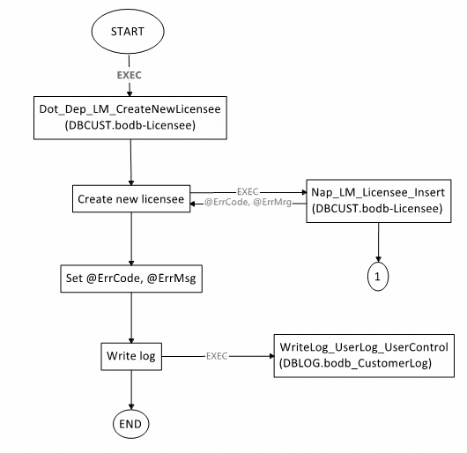

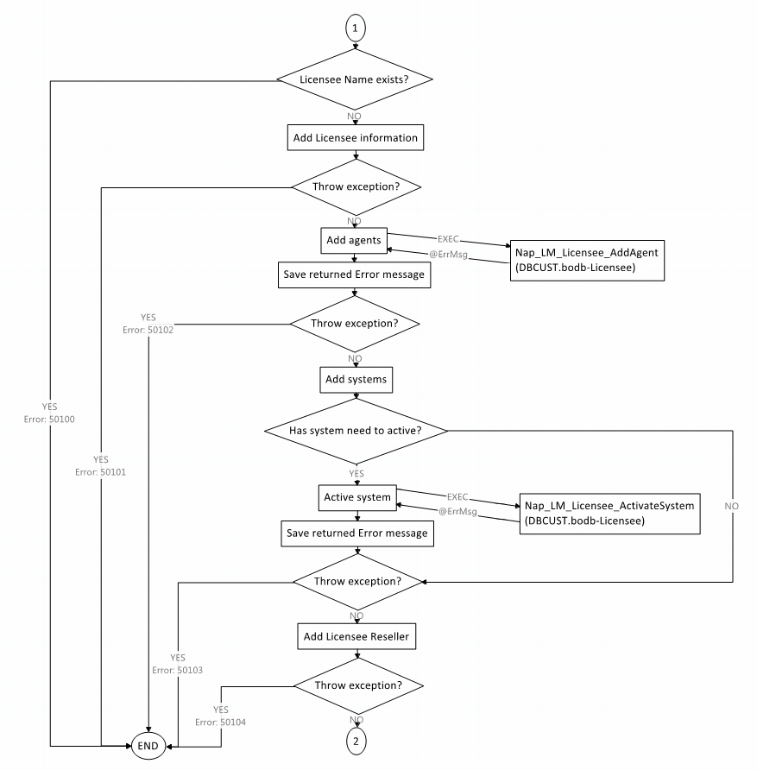
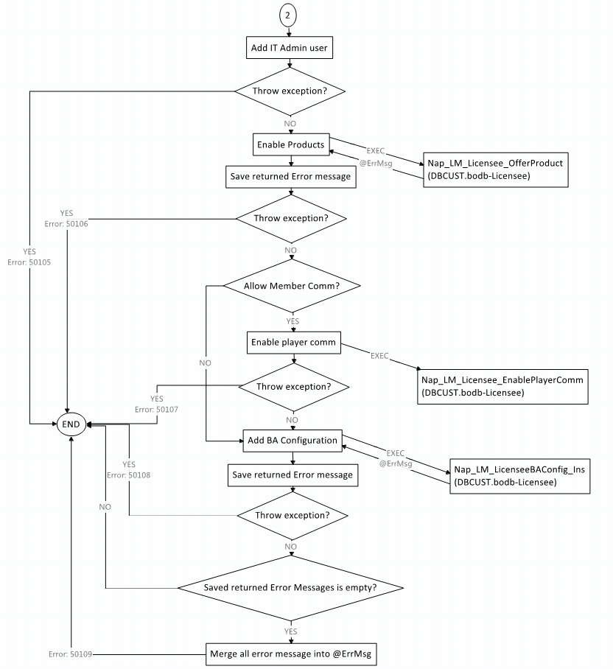

3.13. Nap_LM_Licensee_Insert.
Functionality:
- Add licensee information
- Add Licensee agents
- Active Licensee in systems
- Add IT Admin users
- Enable Products in LAP
- Enable Player comm
- Add BA configuration
SP name: DBCUST.bodb-licensee.dbo.Nap_LM_Licensee_Insert
Input parameters:
Parameter | Type | Mandatory | Description
LicenseeName | VARCHAR(50) | Yes
SuperWildCard | VARCHAR(100) | No | - Super customer name  - Use to add agents for licensee  - Default: Licensee Name + 'Super'
LicenseeType | String | Yes | - Server Group (Boping, OneWorks, Zelianta)
IsSpecial | Bit | No | - Use to separate agents from 12bet branches by updating agent description with normal/affiliate/banner/income access  - Only use for 12bet  - Default: 0
ProductCode | VARCHAR(100) | No | - Offered products. Ex: SB,BA,VS,CO
SystemisActive | VARCHAR(100) | No | - Systems will be activated  - Default: LRF,OA
IsAllowMemberComm | Bit | No | - Enable player comm if set = 1  - Default: 0
EffectiveDate | Date | No | - Effected date of licensee and offered products
Description | VARCHAR(100) | No
BrandName | VARCHAR(100) | No
CompanyName | VARCHAR(100) | No

Return parameter:
Parameter | Type | Mandatory | Description
ErrCode | Int | No | Error Code
ErrMsg | NVARCHAR(MAX) | No | Error Message

3.14. Nap_LM_Licensee_AddAgent.
Functionality: Add Licensee agents
SP name: DBCUST.bodb-licensee.dbo.Nap_LM_Licensee_AddAgent
Input parameters:
Parameter | Type | Mandatory | Description
LicenseeName | VARCHAR(50) | Yes
SuperWildCard | VARCHAR(100) | Yes | - Super customer name  - Use to add agents for licensee  - Default: Licensee Name + 'Super'
Currency | INT | No | - Currency Id
IsSpecial | Bit | No | - Use to separate agents from 12bet branches by updating agent description with normal/affiliate/banner/income access  - Only use for 12bet  - Default: 0

Return parameter:
Parameter | Type | Mandatory | Description
AffectedRows | Int | No | Number of agents added
ErrMsg | NVARCHAR(200) | No | Initial company winlimit fail

3.15. Nap_LM_Licensee_ActivateSystem.
Functionality: Active Licensee in systems
SP name: DBCUST.bodb-licensee.dbo.Nap_LM_Licensee_ActivateSystem
Input parameters:
Parameter | Type | Mandatory | Description
LicenseeName | VARCHAR(50) | Yes
SystemName | VARCHAR(100) | Yes | - List of system that will be activated. Ex: LRF,OA,Accounting

Return parameter:
Parameter | Type | Mandatory | Description
ErrMsg | NVARCHAR(200) | No | - “Licensee is invalid or active system list is empty”  - “Invalid systems(s): (list of invalid system)”

3.15. Nap_LM_Licensee_OfferProduct.
Functionality: Enable Products in LAP
SP name: DBCUST.bodb-licensee.dbo.Nap_LM_Licensee_OfferProduct
Input parameters:
Parameter | Type | Mandatory | Description
LicenseeName | VARCHAR(MAX) | Yes | - List of licensee name. Ex: Licensee1,Licensee2,Licensee3
ProductCode | VARCHAR(MAX) | Yes | - List of product code. Ex: SB,BA,CO
EffectiveDate | DATE | No
IsPullService | BIT | No | - Default: 1

Return parameter:
Parameter | Type | Mandatory | Description
ErrMsg | NVARCHAR(MAX) | No | - “Invalid licensee(s): (list of invalid licensee)”  - “Invalid product(s): (list of invalid product)”  - “Licensee(s) do(es) not have reseller: (list of licensee)”

3.16. Nap_LM_Licensee_EnablePlayerComm.
Functionality: Enable Player comm
SP name: DBCUST.bodb-licensee.dbo.Nap_LM_Licensee_EnablePlayerComm
Input parameters:
Parameter | Type | Mandatory | Description
LicenseeName | VARCHAR(500) | Yes | - List of licensee name. Ex: Licensee1,Licensee2,Licensee3

3.17. Nap_LM_LicenseeBAConfig_Ins.
Functionality:
Add BA configuration
SP name: DBCUST.bodb-licensee.dbo.Nap_LM_LicenseeBAConfig_Ins
Input parameters:
Parameter | Type | Mandatory | Description
LicenseeID | INT | Yes
groupa | DECIMAL(9,8) | No | - Default: 0
groupb | DECIMAL(9,8) | No | - Default: 0
groupc | DECIMAL(9,8) | No | - Default: 0
groupd | DECIMAL(9,8) | No | - Default: 0
1x2Comm | DECIMAL(9,8) | No | - Default: 0
OtherComm | DECIMAL(9,8) | No | - Default: 0
ugroup | VARCHAR(3) | No | - Default: 'a'
EnableBA | BIT | No | - Default: 0
UserID | INT | Yes | - Licensee user – user add BA configuration
IP | VARCHAR(50) | No | - IP address

Return parameter:
Parameter | Type | Mandatory | Description
ErrMsg | NVARCHAR(100) | No | - “Invalid Licensee”  - “BA congiguration has been inserted before”

